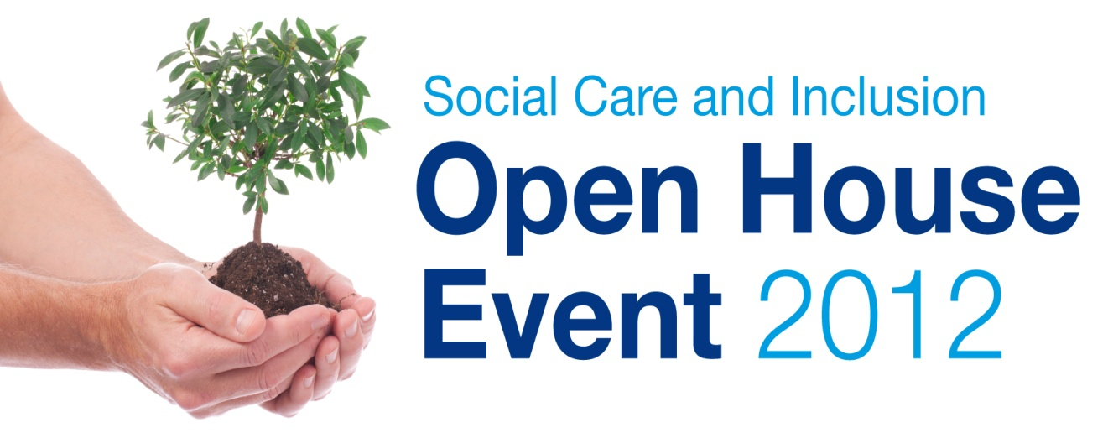
Post event Evaluation

Headlines from Open House 2012

We had 125 people sign in at the event (not all attendees will have done so) – lot of competition today in terms of other events, big Provider Services Training on at the Innovation Centre and of course the ILC event.

23 people shared success stories on the celebration wall.

We had no questions posted on the question wall.

We received 13 completed evaluation forms – a bit disappointing but we will nevertheless include the composite feedback into a post event report which will go on our website along with photographs. www.walsallsocialcareworkforce.co.uk

Anecdotally – it was reported that stall holders were very engaged and keen to share their practice/good news stories.

We have drawn the quizzes too!

Workforce Development Meet the Team Quiz
No – One correctly guessed all seven team members, therefore the prize was given to the person how guessed the most correctly.
The winner was - Susan Jones, who correctly guessed four right answers and won a box of Biscuits.

Anagrams Quiz
People were asked to take part in an anagrams quiz; there were a high number of entries to the competition in comparison to previous years. Please see below for a list of the correct answers. There were four winners drawn from random; our congratulations go out to-
Stacey Senior – 1st prize winner - £20 voucher
Colin Frenzel, Becky Thomson and Bill Henwood – all won £20 vouchers.

Anagram | A clue | Correct Answer
Very core  1 word 8 letters | As in getting better | Recovery
Casual ill clown  2 words 7 & 7 letters | Our Local Authority | Walsall Council
Know forever completed  2 words 9 & 11 letters | How to match workers skills, knowledge to the needs of our business | Workforce development
Occasional inland cruise  4 words 3rd is And | Our Directorate Service Area | Social Care and Inclusion
No Hope Sue  2 words 4 & 5 letters | This Event | Open House
Valid pause  2 words 4 & 6 letters | He’s from Oldham too | Paul Davies
Lit no corn  2 words 2 & 7 letters | Think Local  Act Personal | In Control
Bar element  1 word 10 letters | Getting back/maintaining independence | Reablement
Work is oracle  2 words 6 & 6 letters | Qualified Professional role within our service | Social worker
Mini work globe  2 words 6 & 7 letters | Hot desking | Mobile working
Ode costume focus  2 words 7 & 8 letters | Results Centred | Outcome focussed
Repainted Gloom  2 words 9 & 5 letters | TOM without the T | Operating model
Separation Lions  1 word 15 letters | Agenda for Change in social care services | Personalisation

Celebration Wall
23 People shared on our Celebration wall, It is fantastic to read about some of the hard work that is being done by our colleagues.
Team Name: Community alarms
Our Achievements: Our smoke detectors have saved the lives of two of our service users recently –where the service user has fallen asleep, and a fire has broken out. We called the fire service immediately.
The fire service have said that if it wasn’t for our prompt action both of the incidents could have resulted in fatalities
Team Name: Initial Assessment
Our Achievements: Successful 1st year student on placement with IAT

Team Name: Short Term Breaks
Our Achievements: We are proud to have a diverse group of foster carers – single male, single female, couples, and ethnicity
Team Name: Initial Intake team
Our Achievements: Team members participating in different working groups such as PARIS user group, Paperwork review group, Palliative care group and Reablement transition LD ‘Walsall central hub’

Team Name: Initial Intake team
Our Achievements: Four Apprentices offered on job training with IAT

Team Name: Sensory support
Our Achievements: A Deaf wheelchair user has been supported to move from unsuitable accommodation to a ground floor flat adapted to meet their needs.
The previous home was over 2 floors and was accessible by lift. However, the lift was not reliable and on the occasions that there was a breakdown the client had to slide down the stairs to exit the property. This caused a very high risk to the client especially in the case of if there was a fire within the property.
The new property now suits the clients’ needs with many adaptations including wider doorways, CCTV for visitor recognition, a hoist for use with the bed, kitchen facilities with the ability to be raised/lowered, a wet room with bidet and a flashing fire alarm.
The client is also now in an area more suitable as it is local to all the amenities the client may need including shops, access to council services and the Deaf community.
This is one example of the achievements our clients have been able to secure through receiving the support from our service. We are able to communicate with the clients in their first language of British Sign Language (BSL) which enables confidence to cooperate with the service and its staff.
Team Name: Community Social Work
Our Achievements: We’re proud to offer a preventative service to individuals, families, carers and communities of Walsall working with adults over 18 helping to reduce isolation and promote social inclusion

Team Name: Workforce Development
Our Achievements: Bringing together a new team. Conducting a learning needs analysis and launching a new website

Team Name: Walsall shared lives
Our Achievements: We continue to provide long and short term placements and day support for people on a successful basis. The people have some really positive experiences, be it general life events, trips out or holidays.
We have also provided some very successful emergency placements and continue to recruit new carers on a regular basis throughout the year.
Team Name: Initial Intake team
Our Achievements: Supports other teams when on training and away days.
Team Name: Adult safeguarding
Our Achievements: The raising of the awareness of adult abuse to the people of Walsall serves to encourage independence and the ability to seek help or support for vulnerable people when required.
‘Mrs A suffered from a disability and lives in the community expressed concerns that she felt that she was being financially abused and that this was causing concern. Mrs A was able to seek support from services in Walsall and was able to regain control of her finances’.
Team Name: Initial Assessment
Our Achievements: Actively worked towards handing no work over to EDT
Team Name: Strategic Development
Our Achievements: Developed Goscote Greenacres Community Farm
Team Name: Review Team
Our Achievements: We helped someone move out of placement into independent living, he now has a job and his independence and very little paid care now. He volunteers too!
Another person used to have a lot of care and through reablement now has very little paid care.

Team Name: Initial Assessment
Our Achievements: Since we have had a worker based at good hope hospital we have not received any fines for delayed discharges.

Team Name: Sensory Support
Our Achievements: We have taught people who are blind or partially sighted to live independently and lead fulfilled lives. You want examples? Come and talk to us!
Team Name: Strategic Development
Our Achievements: Deployed Technology for mobile working

Team Name: Occupational Therapy
Our Achievements: “Enabling the citizens if Walsall to live safely and independently in their own homes”
“Positive interventions to maximise independence”

Team Name: Strategic Development
Our Achievements: Opened the new Independent Living Centre

Team Name: Initial Intake team
Our Achievements: Actively signposting and introducing citizens to universal services and maximising social capital
Team Name: Strategic Development
Our Achievements: 80+ Apprentices recruited

Team Name: Initial Intake team
Our Achievements: IAT actively encouraged personalisation with presentation to MIG
Team Name: Community Catalysts
Our Achievements: Working with over 60 organisations and
individuals to develop their social care enterprise.

